1. Write a recursive python function that takes a parameter list and returns the maximum number stored in the list.
2. Remove all the occurrences of a specific item from the list.
3. 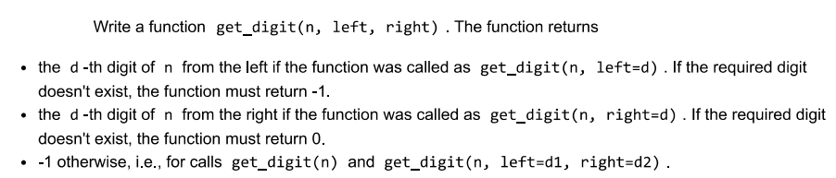
4. Check the maths library version you are using and use the gcd function to find the gcd for given numbers 200,444,66, 28,48. Also find the lcm of given numbers using the relevant function.
5. Find the natural log and log base 10 of the 5 and 75 using relevant functions from the maths module.
6. Use the OS module and files functions to check if the text file named StudentDetails.txt exists In the parent folder of the assignment - 2 folder, if it does not exist create the text file. Add names of 3 students and their birthdates to the file and then close the file. Open the file again and add two more student details to the file. Finally read the details of all the students from the file and display them properly on screen. Return the names of all students in a list named snames.
7. Create a function rever(n) in python that returns the value of the integer argument n with its digits order reversed and sign unchanged (1719 -> 9171).